Technical Documentation

In this document I will show the technical side documentation, and how the database was built and planned, this will also have the SQL statements that were used in the database

Root User:

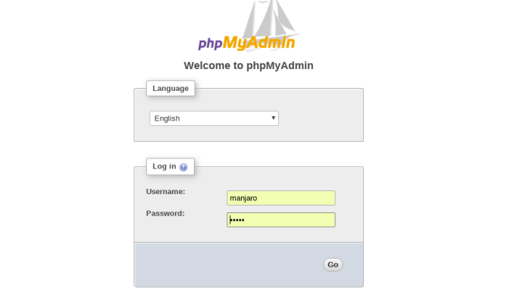

Then, usability of database

1. Clicking the name of the database (middle left screen)
2. Clicking on views
3. Showing the views

If there was any problem call 0798729909 or send an email to adeeb@gmail.com.